What is Esports? CNN defines esports as “the world of competitive, organized video gaming. Competitors from different leagues or teams face off in the same games that are popular with at-home gamers: Fortnite, League of Legends, Counter-Strike, Call of Duty, Overwatch and Madden NFL, to name a few. These gamers are watched and followed by millions of fans all over the world, who attend live events or tune in on TV or online. Streaming services like Twitch allow viewers to watch as their favourite gamers play in real time, and this is typically where popular gamers build up their fandoms.”

This is an accurate overview of what Esports is. In addition, as the report progresses you will be shown aspects from how funding works to how player rates are calculated, and where a lot of the income comes from for organisations running teams.

In esports, it is common for tournament organisers to be late to pay players and organisations. Even to the extent where a popular organisation “Windingo” had to shut down after not being paid $500,000 from WESG who is run by Ali Express.

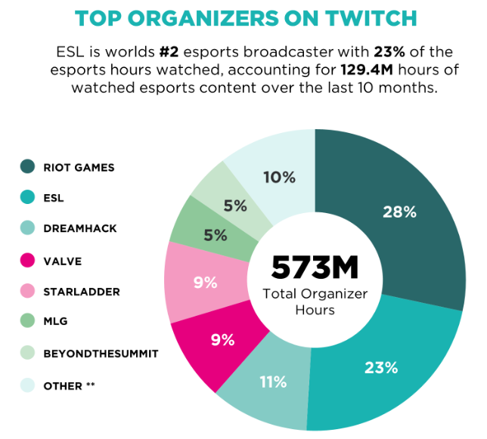It isn’t uncommon for organisers such as WESG, Starladder and ESL, the second biggest organiser for Esports, to do this.

Although it happens more often with players and organisations, it also happens with casters and hosts. This year however, has been different as many people have thought the tournament organisers were “taking the piss” – Vince Hill (Caster).

NewZoo Esports - 2016